1.1

Assuming, after normalising, the X1 and X2 (co-ordinate origin) is (0,0).

Converting them into homogenous co-ordinates

= 0

Therefore,

[ f31 f32 f33] = 0

Finally,

f33 = 0 .

1.2. Given that there is no rotation by only translation which is parallel to x axis.

Therefore,

P1 = K1[I|0]

P2 = K2[I|t]

F = [e’]×P2P1+ = [e’]×K K-1 =

2.1 the 8 point algorithm

F matrix:

[[-5.39510268e-04 -5.34867386e-02 7.19762206e-01]

[-2.43579764e-02 1.45738860e-03 -1.05587609e-02]

[-6.91351246e-01 1.93936474e-02 -4.10639901e-03]]

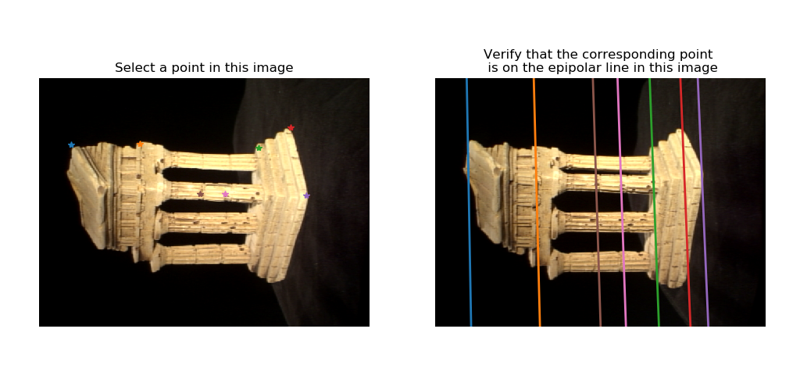

2.2 7 point Algorithm:

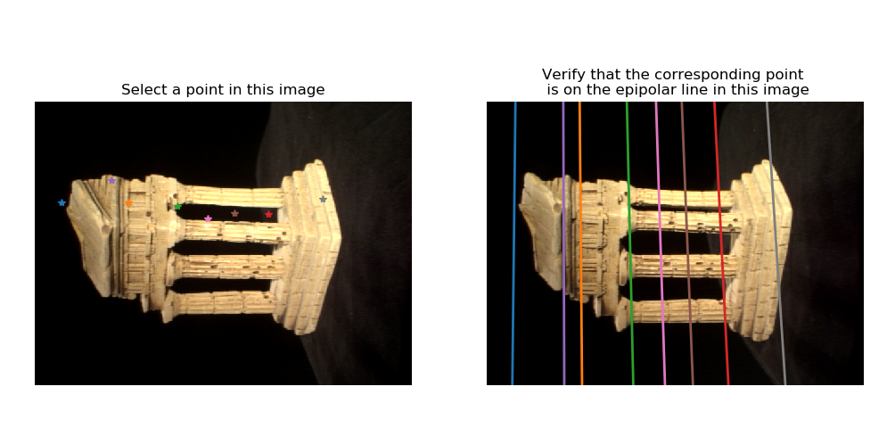

F(seven point) = [[-6.09080639e-09 1.73057621e-08 9.40992608e-04]

[-1.62234195e-07 -8.63467505e-10 1.78627741e-05]

[-9.05544907e-04 -6.71986149e-06 -3.35266556e-03]]

3.1 Essential Matrix Estimation from F and Intrinsics K1 and K2:

[[-3.04477699e-03, -3.02949405e-01, 1.66026654e+00],

[-1.37963814e-01, 8.28452408e-03, -5.12671289e-02],

[-1.66531742e+00, -1.26601678e-02, -1.36557606e-03]]

3.2 Expression for A:

A =

4.1 Epipolar Correspondences;

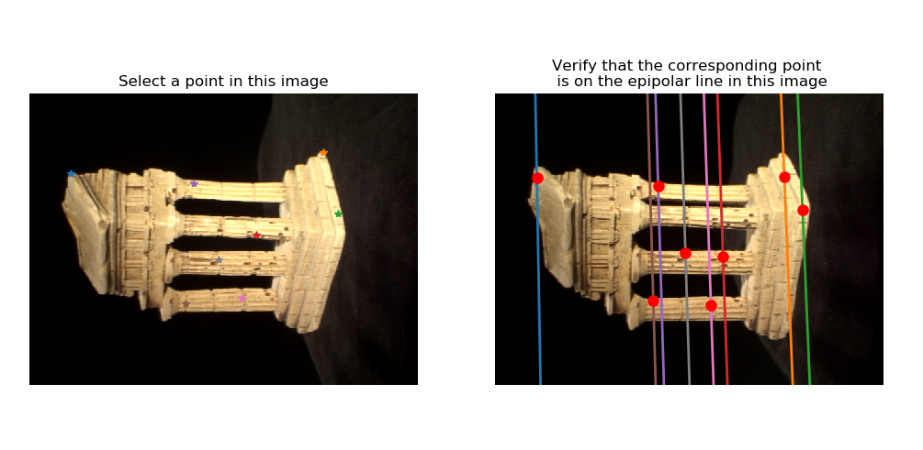

The F, points1 and points2 which were used to generate F is saved as ‘q4_1.npz’

4.2 3D Visualization- Temple Coordinates:

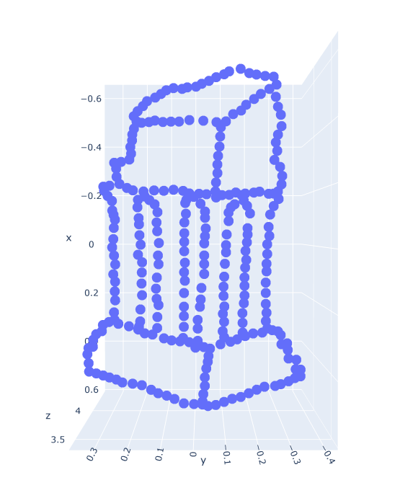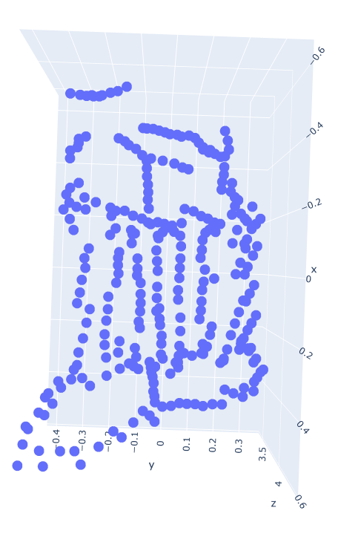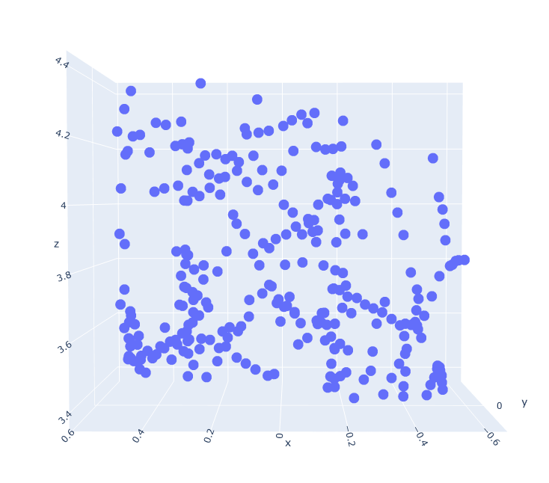

5.1: RANSAC:

Eightpoint with noisy Correspondences:



It can be seen that the eight point works well for noiseless correspondences. But if there is noise like the image above, it seems to give random inaccurate results.

RANSAC 7 point with noisy Correspondences:

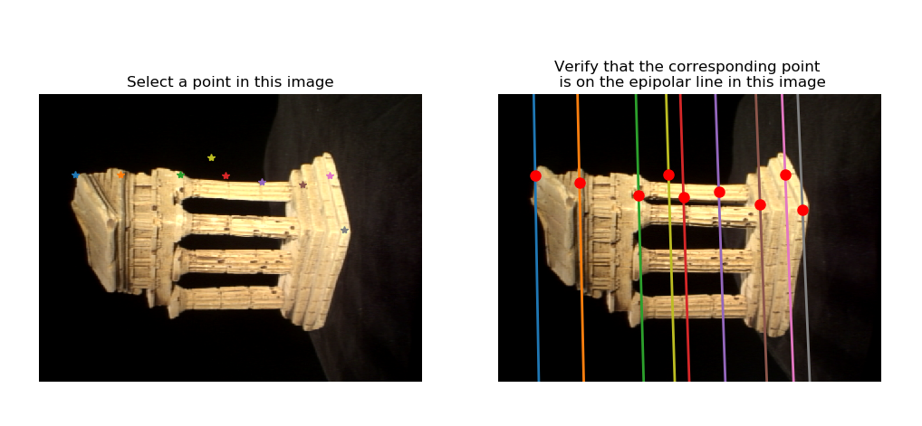

On the other hand, RANSAC when added with 7 point algorithm in order to remove the outliers, gives decent results as it removes noise(outliers) and the f is chosen based on the amount of inliers present.

The error metric used:

Given the noisy correspondences p1 and p2 , generally for the points to be inliers it has to lie on the epipolar line. So that , where f is calculated randomly using 7 point algorithm. Since RANSAC helps us to find the points that lie closer to the line, we use a threshold value (e.g.: 0.001) to say that a point is an inlier if it lies within the threshold limit for a given calculated F, fundamental matrix. So the f with the most inliers is selected and that gives the best estimate of the correspondences.

5.3.

Error before Bundle Adjustment: 27985.398180529548

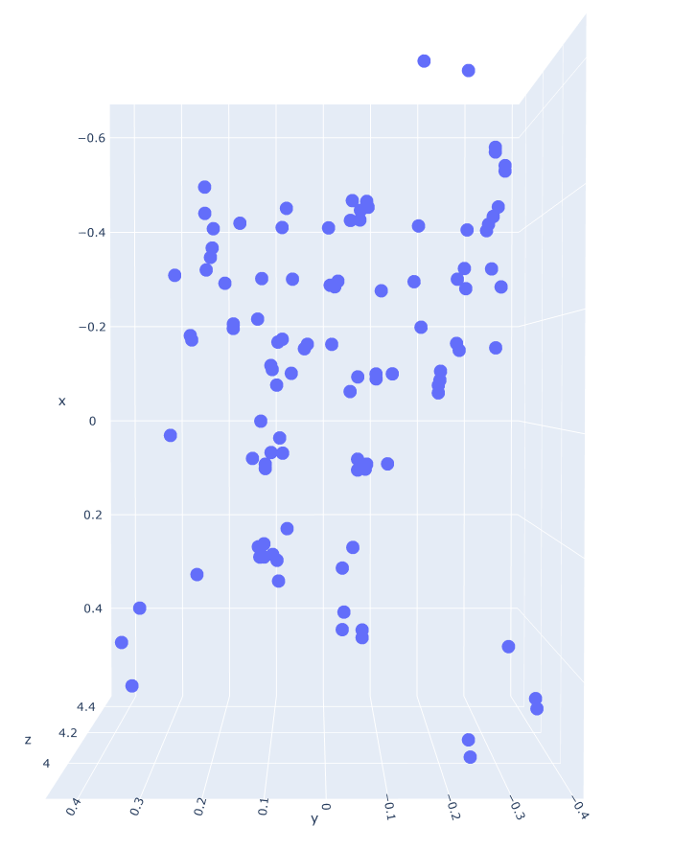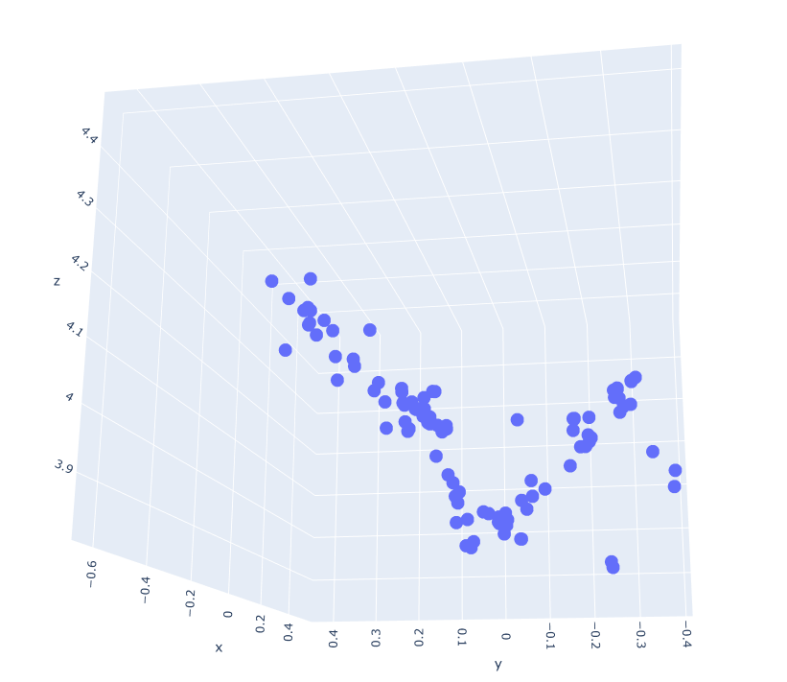

Error after Bundle adjustment: 12.534524154494393

